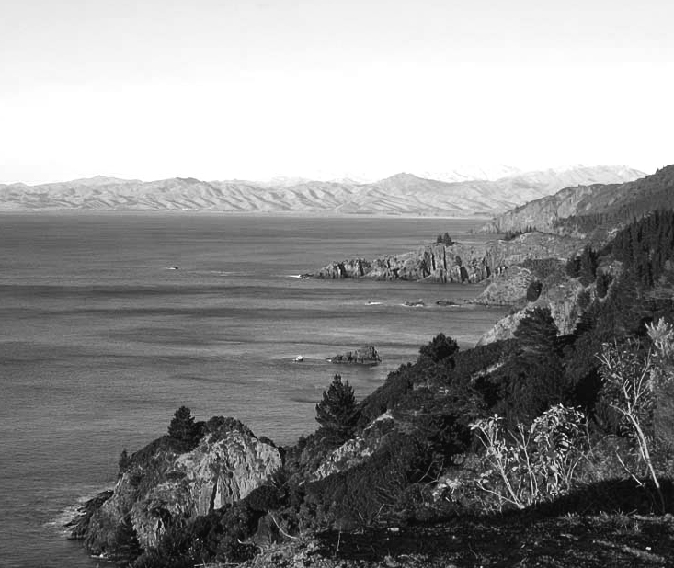Welcome to the May 2014 issue of the Port Underwood Association newsletter.

**Port Underwood Association**

### Contents

Committee

Contact details

Marlborough District plan

Brief review of the draft plan

Roads

Log truck decision and further consultation

Neighbourhood support and Fires

Another fire in Port Underwood

Admin:

And other matters

I hope everybody had a good summer (and early Autumn) in the Port. It has been a busy time for me, but I have really enjoyed my time here.

Treaty settlement

This newsletter contains updates of matters that are familiar to all residents; roads, aquaculture and the District plan. The committee welcomes feedback, contributions from members and suggestions as to what should be included. Contact details are again given below to facilitate this.

What is guardianship?

I had hoped to get the website up and running soon. This will not replace the newsletter but will supplement it. I have, however, been unusually busy at work and have not progressed this yet. It will be coming soon!

Best wishes

John

**Committee members**

President

John Davison jad793@gmail.com

Secretary and Treasurer

Sara Roush sarakenroush@gmail.com

Members

Ken Roush sarakenroush@gmail.com

Ali Kircher kircher@inet.net.nz

**Port Underwood Association contact details:**

port.underwood.association@gmail.com  or

PO Box 59 Blenheim 7240

Annabel Phillipson bel.phillipson@gmail.com

Greg Phillipson embryo.greg@gmail.com

Di Cranfield d.cranfield.cranfield38@gmail.com

Jeremy Ward jeremy@eastbywest.co.nz

David Whyte clintondale@xtra.co.nz

**Treaty settlement**

The Ngati Toa Rangitira treaty settlement settles all historic Treaty grievances. Lands have been vested to Ngati Toa Rangitira along with the sum of $70 million. Furthermore, Ngati Toa Rangitira receives *a Poutiaki* (or guardianship) over the Cook Straight. This includes the costal marine areas of Cook Straight, Porirua Harbour, Port Underwood and Pelorus Sound. There is a considerable lack of knowledge over what guardianship means. It will possibly have an impact upon future development of the coastal area.

The association will seek to meet with Ngati Toa Rangitira to try and ascertain what is planned, what guardianship means etc. If anybody has any further information or relevant contacts please pass this on to the committee.

The full settlement details can be found at the Office of Treaty Settlements' website : [*ots.govt.nz*](http://ots.govt.nz/). Unfortunately, this website has been closed for the past few days for maintenance.

**Marlborough District Council plan 2014/15 – draft**

The council has issued its draft plan. This can be found at: <http://www.marlborough.govt.nz/Council-Publications/Plans-Policies-and-Documents/2014-2015-Annual-Plan.aspx>

The plan includes:

* Highlights of major areas of proposed expenditure.
* The activities Council intends to undertake in the 2014-15 year, levels of service to be provided and the measurement thereof.
* Council’s proposed programme of asset renewal and improvement.
* The budgeted cost of undertaking the activities proposed and related asset renewals and improvements.
* The means of financing the cost of those activities and assets, including rates, fees, charges and debt.

One of the major projects noted (cost $337,000) to improve the way water quality is monitored. It is suggested that this amount will not go far as there is 1,814 of coastline ($185 per km).

$5.5 million is to be spent on drainage, resealing and sealing unsealed roads.

The plan notes that there are c. 900km of sealed road and 640km of unsealed road. It also states that the unsealed roads are a particular challenge due to their changeable nature. An emerging issue is that significant forests were planted in the late 1970s and early 1980s and these will be due to be harvested over the next few years and will have roading effects such as dust, noise, damage and safety.

In addition, NZTA has stated that $1.27 million of funding assistance will not be available. Another funding issue is the expected increased damage to roads due to storms caused by climate change.

Port Underwood is mentioned in the plan as follows:

* Potential for log exports from the port Underwood area has been raised several times and will require careful consideration prior to this taking place;

Any other comments or thoughts on the plan will be welcomed.

**Roads**

Whataroa Forest Harvesting; Road Usage Proposal

The application to allow up to 10 logging trucks a day for harvesting trees was rejected by both the committee and full council. It is understood that residents on the road towards Picton were forceful in their objections. Personally, I was surprised by the rejection and perhaps the learning point from this is that objections can have an impact.

Further consultation

Following the Whataroa harvesting decision the council has written to all who submitted as follows:

Many submissions requested further consideration of the long term management of log transport from the Port Underwood area.  Council is similarly concerned about the increasing forestry harvest across the wider Marlborough District and particularly the impact of carting logs by road.

A staff member, Jon Cunliffe – Resource Management Advisor, Assets and Services – has been tasked with undertaking a review of district wide forestry roading issues.  His brief includes harvest forecasts; consequent road use; any safety, dust, road damage, noise or amenity issues which may be expected from that.  Consultation with potentially affected communities and the forest industry will be required.

The council has been contacted and the association will be included in any future consultation following the council’s review of harvest forecasts

**Flagg Bay Fire**

Fire is one of the biggest fears that we all share in a rural area such as ours and we know it can be a dramatic ordeal for anyone involved. We acknowledge the loss that the Flagg Bay landowners have suffered this past year and particularly the loss of Ken & Libby Prain’s home.

As a follow up to the fire:

We donated $500.00 to the Marlborough Fire fighters social fund in appreciation of their volunteer efforts.

We learned that it is advisable to have receipts, serial numbers and pictures of valuables kept in a fire proof location to help in dealing with insurance company claims.

Brian Tapp of Marlborough Lines has advised us that if trees are in power lines they should be cut down or trimmed by a licenced arborist such as Marlborough Lines.

Remember, communication is the key to no one getting hurt in a fire. Use the Neighbourhood Support phone number list which is supplied each year to alert neighbours by phone. If phones are out, yell or honk your horn to attract attention, knock on doors if there is time.

Enclosed with this newsletter is a brochure on fire retardant natives for anyone thinking of planting near your home.

**NEIGHBOURHOOD SUPPORT**

Thankfully, it has been fairly quiet in Port Underwood recently except that a few Mongrel Mob members were caught poaching paua and a motor was stolen off of a dinghy.

Just as a reminder, it is always advisable to notify your neighbours if someone other than yourselves will be using your batch. Also, if it is an emergency always phone 111.

**ROAD CLOSURE ALERTS**

Due to all of the recent rain we had before Easter the Port Underwood Road had many slips and trees down so was closed from the Picton direction for a short time. Many of you didn’t know how to find out about road closures, so hopefully the following will help in the future.

**If you have access to a computer check**  [www.marlborough.govt.nz](http://www.marlborough.govt.nz)

A section containing a link to road alerts is located on the right hand side of the home page. This gives information on local road closures as well as links to national highways.

**If** **no access to a computer**  the following phone numbers might be useful:

**Marlborough roads** (9:00Am to 5PM Monday-Friday except holidays) 0800 627 573 or 03 520 8330 Blenheim

**Marlborough Council** (24 hours 7 days a week including holidays) 03 520 7400

**HEBS Contracting** (9:00Am-5:00PM Monday-Friday) 03 579 4253 Blenheim. This is the company that Marlborough Council has contracted to clear the slips and trees.

**National Highways** (24 HOURS 7 DAYS) 0800 444449

**Sounds Advisory Group meeting in Port Underwood**

A meeting of the Sounds Advisory Group, open to the community, was held in Port Underwood on 24th February. A number of issues were discussed as described in the enclosed notes of that meeting. Feedback from the Marlborough District Council members and the community members indicate it was a very worthwhile meeting. Thank you to those members of the public that were able to attend.

**Other matters**

SUBS REMINDER

Just a reminder for those of you that haven’t had a chance to pay your subs yet that the $20.00 subs for 2014 are now due. Please mail a cheque along with the enclosed sub form to The Secretary, Port Underwood Association, P.O. Box 59, Blenheim 7240.

Alternatively you can do a direct deposit into the Port Underwood Association account , Westpac Bank Blenheim, 030599: 0216931 00. Please be sure to quote your surname and Bay as references. Then, could you email any changes or additions to your personal details to [port.underwood.association@gmail.com](mailto:port.underwood.association@gmail.com)