**Locals want action on dangerous road where cars plunge over side**

It is a road renowned for its steep drops and sharp bends and only an urgent upgrade will help save lives, residents warn.

A potentially deadly road needs urgent upgrades and repairs to help prevent drivers plunging off the edge.

Ten crashes in 18 months on the Port Underwood Rd in Marlborough have prompted anxious residents to call for improved safety measures.

Port Underwood resident John Davison said it was only a "matter of time" before someone died.

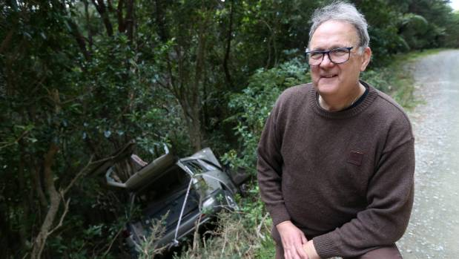

SCOTT HAMMOND/STUFF

Port Underwood resident John Davison believes it is only a "matter of time", before a driver is killed on the road.

But upgraded safety barriers and sealed roads could help make a big difference, he said.

"The road has got a few barriers in rougher areas, but these are wooden fences that take one hit and shatter.

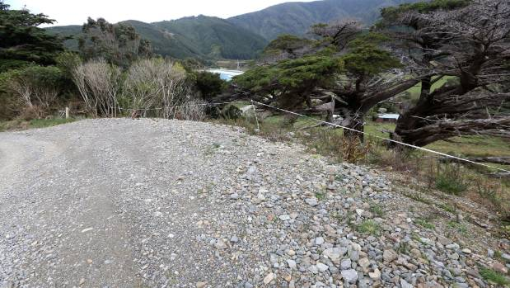

SCOTT HAMMOND/STUFF

An edge of the Port Underwood Road which drops down to Robin Hood Bay marked by tape.

"Some are flimsy things that were put in a couple years ago, and haven't been upgraded since. They don't stop a vehicle at speed.

"People aren't taught to drive on roads like that," Davison said.

In the last 18 months he said he had witnessed four cars stuck partly over the bank and six cars plunge over the edge.

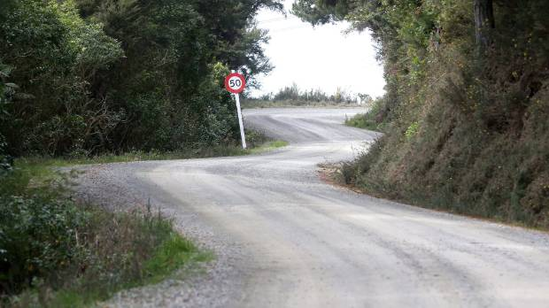

SCOTT HAMMOND/STUFF

A stretch of Port Underwood Road leads to an unbarricaded edge which drops steeply the ocean.

The road was commonly used by tourists looking to fish, dive or camp over the summer months, he said.

"It's one of the easiest roads to get to for the [Marlborough] Sounds, so we get quite a lot of traffic through here.

"People drive as if it's a state highway.

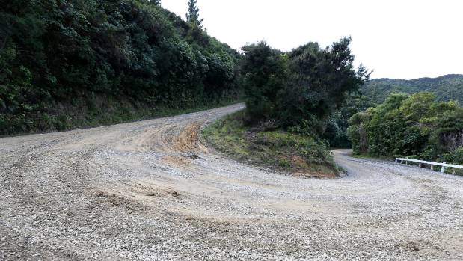

SCOTT HAMMOND/STUFF

Port Underwood Rd has no shortage of hair pin corners.

"If you drive too quickly, you just go straight over the bank. There's nothing to stop you going straight down except a couple of trees."

Port Underwood resident Wayne Boustridge​ said the road was not designed to take the amount of traffic it received, and infrastructure had not kept pace with demand.

He suggested a better traffic system be introduced, as at the moment people were not bound to report incidents over a certain threshold to the police.

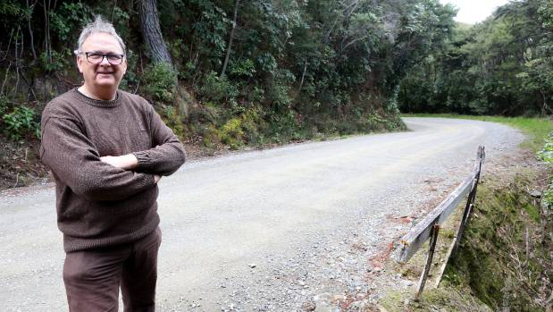

SCOTT HAMMOND/STUFF

The old wooden barriers along Port Underwood Road need to be urgently upgraded says resident John Davison.

"If no one knows where the hotspots are, then how can we design the infrastructure to meet the changing needs and meeting demands?" Boustridge said.

Crash data from New Zealand Transport Agency's (NZTA) crash analysis system showed there were eight accidents on the stretch since January, 2017.

And 47 vehicles had been involved in accidents since January 2000. The NZTA website said not all crashes were reported to police , with non-fatal crashes believed to be under reported. Ten of those were classed as minor accidents, and one as serious.

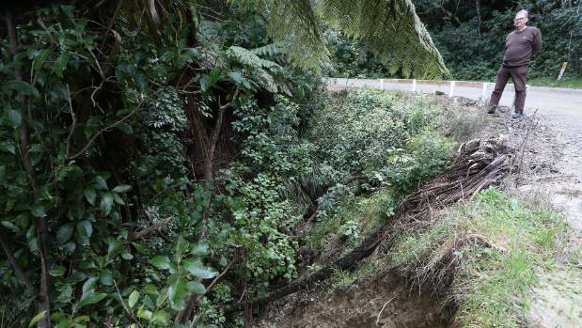

SCOTT HAMMOND/STUFF

Wet weather has left a number of slips along the Port Underwood Road which need to be sorted says resident John Davison.

Long-time Port Underwood resident Ken Roush said while Marlborough Roads was "good" at responding to road issues, he found road maintenance was often left to the last minute.

"A lack of foliage cutback alongside the road means some of the foliage is quite high and you can't see where the road edge is," Roush said.

The road could also get corrugated, or uneven, and driving too fast over corrugations could cause the car to "jump sideways", he said.

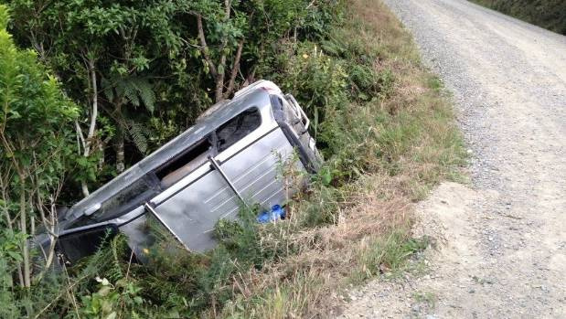

JOHN DAVIDSON

A car rests on its side on Port Underwood Road after crashing off the road.

"There are a number of places where there aren't barriers, and the outside edge has fallen away and into a drop," Roush said.

A council spokeswoman said staff had identified areas for improvement.

She said Port Underwood Rd had suffered some "major storm damage" thanks to bad weather in June and July, including damage to the outside edge of the road.

"There are a number of locations where slips have come down in the road, water has run along or across the road causing damage to the road surface and drainage systems," she said.

"Work crews are endeavouring to get reinstatement work completed as soon as possible, however, with the huge task in front of them works need to be prioritised."

Until the reinstatement of the new walls happened, sites would be signed and coned-off to warn drivers of the potential hazards, she said.

She said irrespective of the signage, the council wanted drivers to take extreme care.

"Port Underwood Road between Whites Bay and Oyster Bay is an unsealed, narrow, winding and in places steep, rural road," she said.

"It requires extreme care and concentration, and low speeds are essential to ensure safe travel."

(From Stuff 22 August 2018)