Carrying Capacity of Western Arm, Port Underwood
By
Kenneth R Roush

This calculation is in response to the carrying capacity calculation provided by Dr. Hartstein for the applicants. I am not a marine expert. However I have a degree in Engineering and am familiar with mathematical modelling. I am aware that the input parameters need to be realistic in order to obtain a meaningful result. I am also not a mussel farmer and therefore I have relied on Dr. Hartstein’s data for inputs in relation to mussels and mussel farming. Where Dr. Hartstein and I differ is that I have followed Dr. Steve Urlich’s direction and made a carrying capacity calculation based on where this application is located, that is the Western Arm of Port Underwood. It is my opinion that Dr. Hartstein’s calculation based on the entirety of Port Underwood is too broad brushed to have a meaningful result for the locality of this application.

The applicants for an extension, U180102, to an existing mussel farm have been asked to supply more information about the effects of the mussel farms on the carrying capacity of the Western Arm and Port Underwood. Dr. Neil Hartstein has provided a calculation based on the Pelagic Effects Criterion of the Aquaculture Stewartship Council (ASC) Bivalve Standard 2012 (version 1.0 Jan.2012) for the entire Port Underwood area.

He has accepted the method and assumptions used by KCSRA in other calculations and therefore I have duplicated this method using a more valid area of influence which I will describe below.

In performing the calculation for determining the effect on carrying capacity it is important to determine the area of mussel farming influence. As noted previously in the Port Underwood Association submission the Cawthorn report (Hadfield M. 2014. An assessment of phytoplankton depletion due to Port Underwood marine farms. Prepared for Property and Land Management Services Ltd. NIWA Client Report NEL2014-005. [Council record: 15206310].) shows the area of influence of mussel farming in the Eastern Arm with high effect in areas close to the mussel farms. It can logically be seen (and suggested by Dr. Urlich) that mussel farming in the Western Arm will have a similar pattern and that is the area that should be scrutinised.

In Appendix 1 of the ASC Standard the method for determining the radius of influence is:

Mean current speed at the farm x 2 tidal cycles (i.e., 25 hours if the M2 tide is dominant)

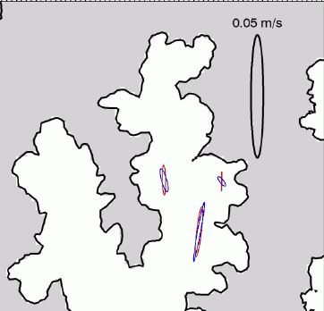

Using the diagram above showing the current speed in the Eastern Arm, also from the M. Hadfield report, and assuming that the Western Arm is similar to the Eastern Arm, as has been suggested by Dr. Urlich in his comments, it can be inferred that the mean current speed at the farms will be 0.01metres/second. Thus -

Radius of area of influence = 0.01m/s x 3600s/hr x 25hr= 900metres

Then using the nautical chart below (at a much closer scale) it can be measured that the area of influence at a 900 metre distance, denoted by the black line, is 4,590,000 m² with a low tide volume of 45,730,000 m³. Agreeing with Dr. Hartstein that the average tidal rise is 1.4m gives a high tide volume of 52,156,000m³.

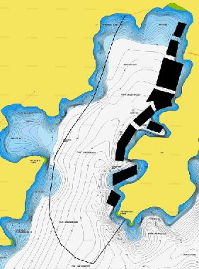

The actual ASC calculation gives the ratio of the Clearance Time to the Retention Time (CT/RT) where:
Clearence Time is the number of days for the bivalves to filter a volume of water, and
Retention Time is the number of days to flush that volume of water.
If this ratio is less than 1 the farmed stock may be dominating the nutrient levels to the detriment of the native species.

CT (clearance Time) = V_{T} (total volume of water at high tide) divided by N (number of bivalves) times C (clearance rate).

V_{T} = 52,156,000,000 litres

N = Hectares of mussels times number of mussels per hectare = 53 x 2,047,080 = 108,495,240 where hectares of mussel is 61 hectares consented less 12.5% for warp line area and mussels per hectare is from Dr. Hartstein and KCSRA.

C = 200 litres per mussel from Dr. Hartstein and KCSRA.

CT = 52,156,000,000 divided by (108,495,240 times 200) = 2.403

RT (Retention Time) = -1 times tidal cycle (0.5 days) divided by the natural log of (the volume of water at low tide divided by the volume of water at high tide).

RT = -0.5 divided by ln(45,730,000,000/52,156,000,000) = -0.5 / -0.13 = 3.82

Therefore CT/RT = 2.403/3.82 = 0.63.

This is significantly below 1 and therefore this calculation shows that for the Western Arm area of Port Underwood the mussel farming in that area is having a significant impact on not only the production carrying capacity but also the ecological carrying capacity.

While viewing the tidal flows which occur in a mainly north/south direction it would be possible to suggest that the area of influence would be even less than 900 metres to the west of the mussel farms as there is very little water flow in the westerly direction. However to take an opposite approach I have also made the ASC calculation by including all of the Western Arm. The significant values are:

Area at low tide = 6,010,000 m²
Volume at low tide = 53,150,000 m³
Volume at high tide = 61,564,000m³

The other values remain the same. Therefore

CT = 61,564,000,000 / 21,699,048,000 = 2.84

RT = -0.5 / ln(53,150,000/61,564,000) = -0.5 / -0.147 = 3.4

and CT/RT = 2.84/3.40 = 0.835

Again below the threshold of 1.0.

Both of these calculations lead to the conclusion that it is very likely that mussel farming is having a negative effect in the Western Arm of Port Underwood.

